Bellevue Council PTSA and Camp Kindness Counts are partnering to run a district-

wide Bellevue Kindness Challenge from January 23- February 10 th . There are 2 parts

to this challenge. The first is to involve students in a project encouraging kindness

in school. The second is to learn about and support impactful organizations which

make a difference in our Bellevue community. Let’s make a difference TOGETHER!

As part of this district-wide PTA project, Spiritridge PTSA has selected to support:
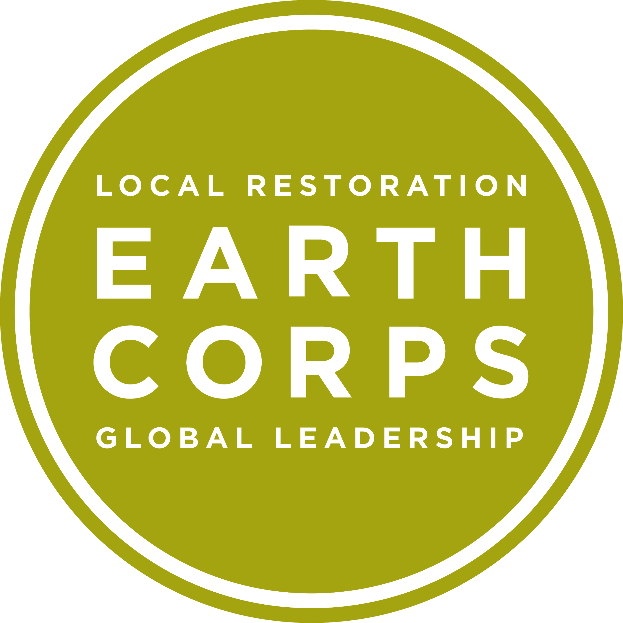
EarthCorps' mission is to build a global community of leaders through local environmental service. Based in Seattle, EarthCorps trains emerging environmental leaders from across the United States and around the world and engages more than 10,000 volunteers each year to restore natural areas around the Puget Sound region.

Our Kind Act: We will create thank you cards for EarthCorps volunteers and staff. Spiritridge PTSA volunteers will have a table and cardmaking supplies available during recess for students to create cards expressing their thanks to EarthCorps for thoughtful stewardship of our Earth.
How This Helps: Your kindness will bring happiness to all the hard-working people who dedicated their days to making sure our community has a healthy green space to live and play in.
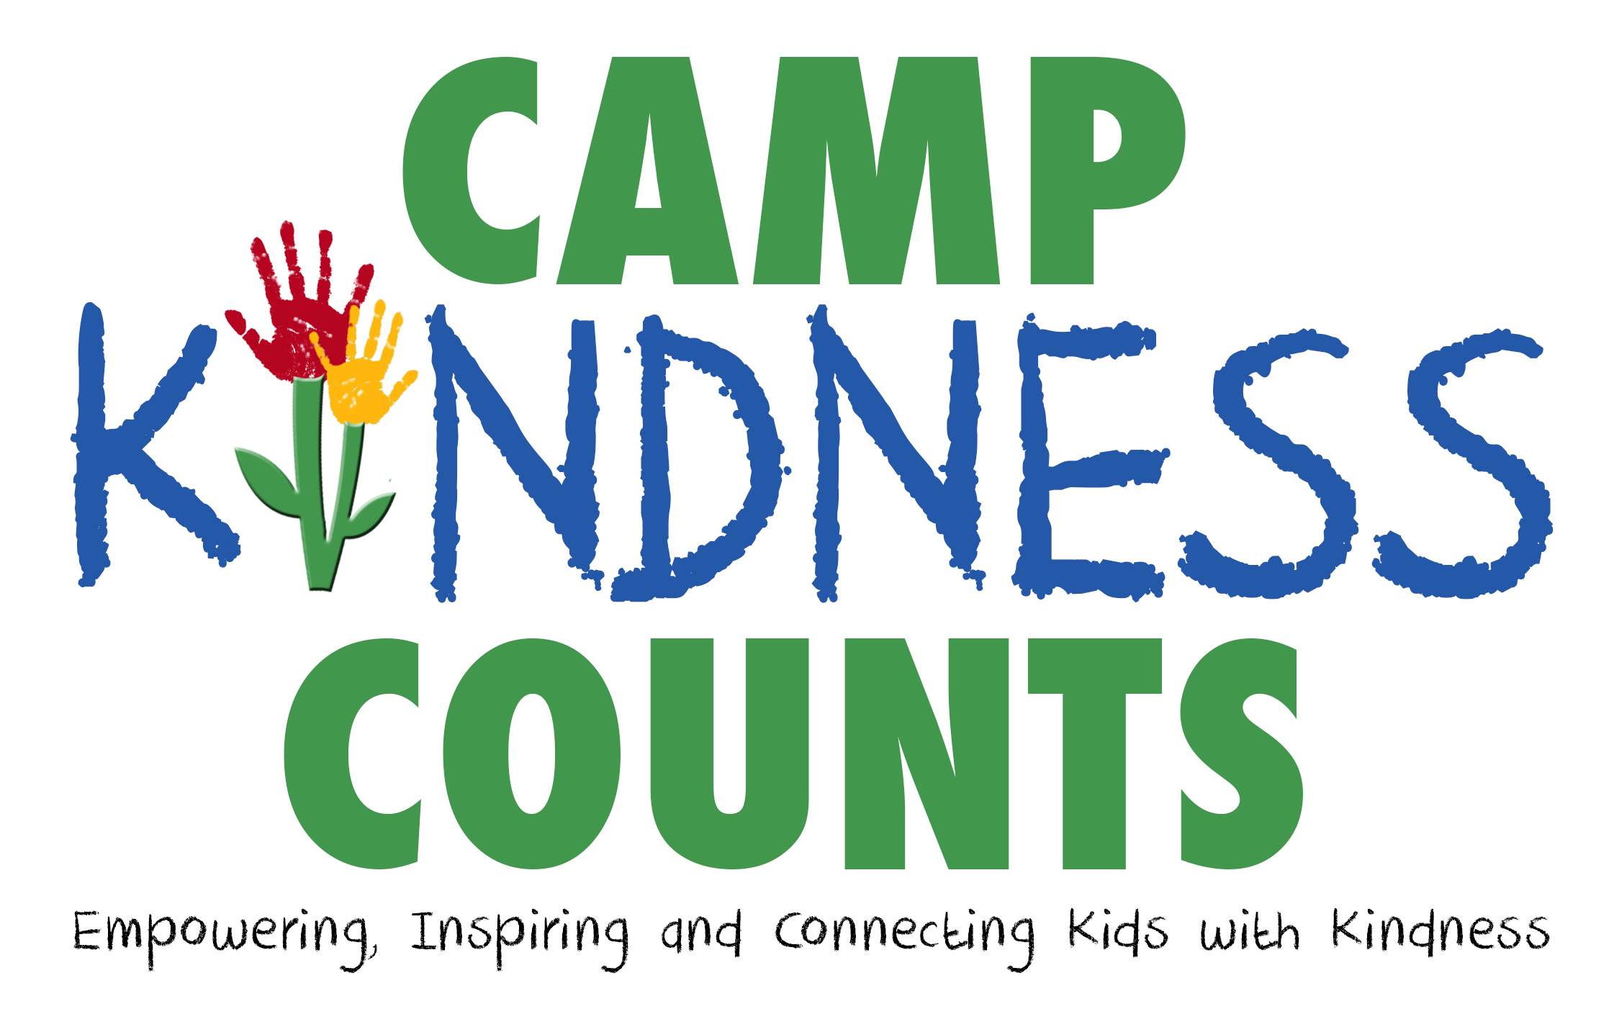
Other Ways Your Family Can Get Involved: Check out our volunteer opportunities on our website: http://www.earthcorps.org/volunteer/calendar/2017/1/

